FEEDBACK FROM PEER AT AXWAY
WHO RECENTLY LEFT TO JOIN BOOMI

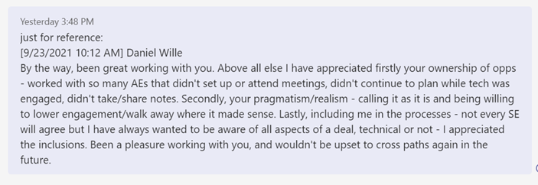

Daniel Wille
[9/23/2021 10:12 AM]
By the way, been great working with you. Above all else I have appreciated firstly your ownership of opps - worked with so many AEs that didn't set up or attend meetings, didn't continue to plan while tech was engaged, didn't take/share notes. Secondly, your pragmatism/realism - calling it as it is and being willing to lower engagement/walk away where it made sense. Lastly, including me in the processes - not every SE will agree but I have always wanted to be aware of all aspects of a deal, technical or not - I appreciated the inclusions. Been a pleasure working with you, and wouldn't be upset to cross paths again in the future.

